PROJECT DOCUMENTATION

CUSTOMER MANAGEMENT SYSTEM

Project Management Plan

Customer Management System aims to login,insert,update,delete and logout the list of customer details. The system deals with three user profiles:admin,manager,employee where admin can insert,update,delete and can view all the customer details,manager can add and view the details and employee can only view the customer details.

Requirements Specifications

The main requirement of the system is to manage the customer details.

Analysis

Customer Management System aims to manage the details of the customer. It consists of mainly four functionalities:

- Adding Customer Details:
Adding the customer details by administrator and manager where details includes Customer Name, City, Country, Phone no, Email.

- Updating the Customer Details:
Administrator can update the details of customer.

- Deleting the Customer Details:
Administrator can delete the customer record.

- Viewing the Customer Details:
Administrator,Manager and Employee can view the customer details.

Use Case Diagram
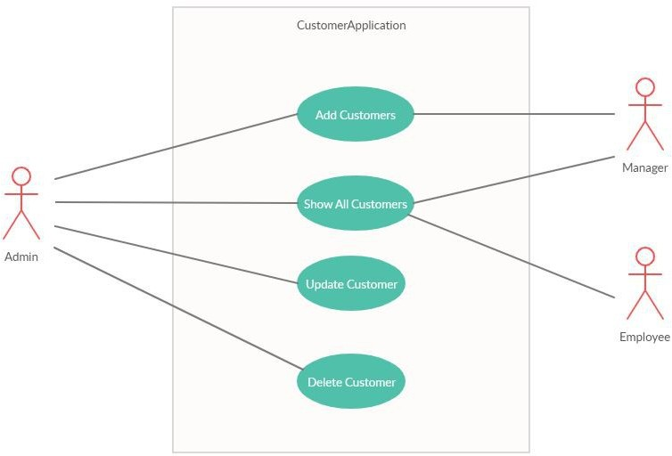

Design

Back end database of Customer Management System is hibernate. It consists of two relational tables are users and customers
User Entity:

This entity contains the properties:name,email,password,profile of the user and the boolean flag isactive. Username and password is used to login to the system.
User profiles can be administrator,employee and manager.

Class Diagram

Implementation

The system is implemented using spring framework and hibernate. Front end of the system is implemented by Bootstrap.
This contains the following modules:

- Login module:

User logs into the system using username and password. He/She views the system according to his profile.

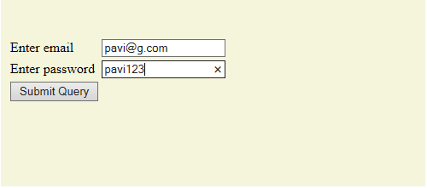

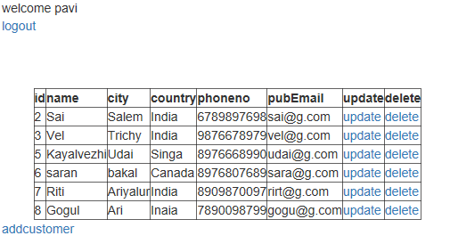

- Adding Customer module:

Name,City,Country,Phone No,Email of the customer are added to the system. Administrator can add the details.

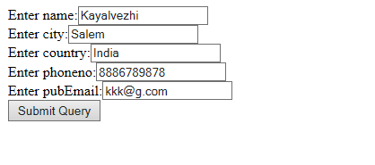
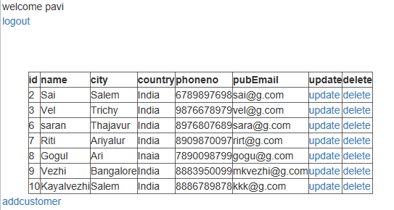

- Updating Customer module:

Administrator updates the customer details. City of Customer with id 6 is updated.

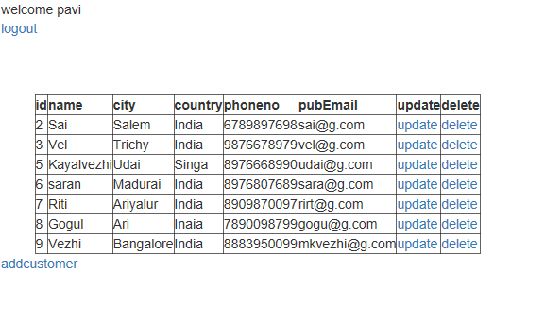
- Deleting Customer module:

Administrator can delete the customer record. Record with customer id 5 is deleted.
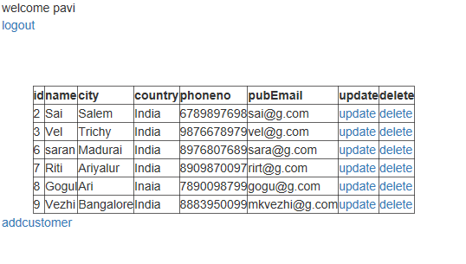

- Logout module:

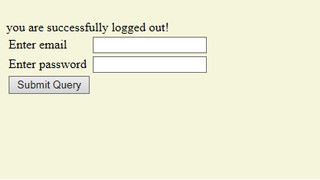

Conclusion

The Customer Management Application is designed to manage the details of the customer,which gives the provision to add,update,remove and view the customer details as per the status of the user profile.

